Riphah Konnect

By:
Moiz Ahmad Abbasi
45499
Obaidullah Arshad
44316
Syed Airaf Khan
47647
Supervised by:
Mr. Raja Jalees-ul-Hussen Khan
Senior Lecturer
Faculty of Computing
Riphah International University, Islamabad
Spring 2026

A Dissertation Submitted To
Faculty of Computing,
Riphah International University, Islamabad
As a Partial Fulfillment of the Requirement for the
Award of the Degree of
Bachelors of Science in Software Engineering
Faculty of Computing
Riphah International University, Islamabad
Date: April 2026

Final Approval
This is to certify that we have read the report submitted by Moiz Ahmad Abbasi (45499), Obaidullah Arshad (44316), and Syed Airaf Khan (47647) for the partial fulfillment of the requirements for the degree of Bachelors of Science in Software Engineering (BSSE). It is our judgment that this report is of sufficient standard to warrant its acceptance by Riphah International University, Islamabad for the degree of Bachelors of Science in Software Engineering (BSSE).

Committee:
1 __________________________
Mr. Raja Jalees-ul-Hussen Khan
(Supervisor)
2 __________________________
Dr. ______________________________
(Head of Department / Chairman)

Declaration
We declare that this report, "Riphah Konnect," is entirely our own work and has not been copied from any other source. We have put in our personal efforts to complete this project and write this report. Our supervisor, Mr. Raja Jalees-ul-Hussen Khan, guided us throughout the process. We confirm that no part of this work has been taken from any other project or published source without proper acknowledgment. If any part is found to be copied, we are ready to accept the consequences. This declaration reflects our commitment to academic honesty.

___________________________
Moiz Ahmad Abbasi
45499

___________________________
Obaidullah Arshad
44316

___________________________
Syed Airaf Khan
47647

Dedication
We dedicate this work to our parents and families, whose prayers, patience, and support made this journey possible. We also dedicate it to our teachers, especially our supervisor Mr. Raja Jalees-ul-Hussen Khan, who guided us with patience and helped us improve at every step. Finally, to our friends and batchmates who kept us motivated throughout this semester.

Acknowledgement
First and foremost, we thank Allah Almighty for giving us the strength and ability to complete this project. We are grateful to our parents for their constant support and encouragement throughout our studies. We would like to express our sincere thanks to our supervisor, Mr. Raja Jalees-ul-Hussen Khan, Senior Lecturer, Faculty of Computing, Riphah International University, for his guidance, feedback, and patience during every phase of this project. His support helped us stay on track and improve the quality of our work. We also thank the faculty of the Software Engineering department for the knowledge and skills they have given us over the past four years.

___________________________
Moiz Ahmad Abbasi
45499

___________________________
Obaidullah Arshad
44316

___________________________
Syed Airaf Khan
47647

Abstract
Riphah Konnect is a web-based platform built for the students and faculty of Riphah International University, Islamabad, providing a dedicated space for academic collaboration and communication within the university. Currently, students rely on general-purpose platforms such as WhatsApp groups and Facebook to organize study sessions and share academic content. These tools are not designed for academic use, have no university-based verification, and make it difficult to keep academic discussions organized. To solve this, Riphah Konnect provides a single platform where students can post academic content on a social feed, form and join study groups, discover and RSVP to campus events, report lost and found items, send real-time messages to peers, and receive suggestions for study partners based on their department and academic profile. Only students and faculty with verified Riphah email addresses can register and use the platform. The system was built using React on the frontend, Node.js with Express on the backend, and PostgreSQL as the database. Real-time messaging is handled through Socket.io. The complete backend API has been implemented and tested, and the frontend has been developed across all six modules of the platform. Riphah Konnect brings together all academic communication needs of Riphah students into one organized and verified platform, which no other tool currently available to our students provides. In the future, we plan to improve the study partner recommendation system, add a mobile version of the app, and look into connecting the platform with university systems such as the LMS.

Table of Contents

Final Approval 3
Declaration 4
Dedication 5
Acknowledgement 6
Abstract 7
Chapter 1: Introduction 12
1.1 Overview 13
1.2 Opportunity and Stakeholders 13
1.2.1 Stakeholders 13
1.3 Motivations and Challenges 13
1.3.1 Motivations 13
1.3.2 Challenges 14
1.4 Goals and Objectives 14
1.4.1 One Platform for Academic Communication 14
1.4.2 Verified University Community 14
1.4.3 Improve Peer Learning 14
1.4.4 Better Campus Engagement 15
1.5 Solution Overview 15
1.5.1 Scope of the Project 15
1.6 Report Outline 15
Chapter 2: Market Survey 16
2.1 Introduction 17
2.2 Literature Review 17
2.3 Summary 18
2.4 References 18
Chapter 3: Requirement Engineering 19
3.1 Introduction 20
3.2 Problem Scenarios 20
3.3 Functional Requirements 21
3.3.1 Authentication Module 21
3.3.2 Social Feed Module 21
3.3.3 Study Groups Module 21
3.3.4 Campus Events Module 21
3.3.5 Lost and Found Module 22
3.3.6 Real-Time Messaging Module 22
3.3.7 User Profile Module 22
3.4 Non-Functional Requirements 22
3.4.1 Password Storage 22
3.4.2 Authentication 23
3.4.3 Email Restriction 23
3.4.4 Error Messages 23
3.4.5 Form Validation 23
3.4.6 Responsive Design 23
3.4.7 Data Consistency 23
3.5 SQA Activities: Defect Detection 23
3.5.1 Test Case Design 24
3.5.1.1 User Registration 24
3.5.1.2 User Login 24
3.5.1.3 Create Post 24
3.5.1.4 Create Study Group 24
3.5.1.5 Join Study Group 25
3.5.1.6 Create Campus Event 25
3.5.1.7 RSVP to Campus Event 25
3.5.1.8 Report Lost/Found Item 25
3.5.1.9 Send Message 26

List of Figures

No figures in Chapters 1 to 3.

List of Tables

Table 2.1: Comparison of Existing Systems ................ Chapter 2
Table 3.1: Problem Scenario 1 ........................... Chapter 3
Table 3.2: Problem Scenario 2 ........................... Chapter 3
Table 3.3: Problem Scenario 3 ........................... Chapter 3
Table 3.4: User Registration Test Cases ................. Chapter 3
Table 3.5: User Login Test Cases ........................ Chapter 3
Table 3.6: Create Post Test Cases ....................... Chapter 3
Table 3.7: Create Study Group Test Cases ................ Chapter 3
Table 3.8: Join Study Group Test Cases .................. Chapter 3
Table 3.9: Create Event Test Cases ...................... Chapter 3
Table 3.10: RSVP to Event Test Cases .................... Chapter 3
Table 3.11: Report Lost/Found Item Test Cases ........... Chapter 3
Table 3.12: Send Message Test Cases ..................... Chapter 3

Chapter 1:

Chapter 1: Introduction

1.1 Overview
Riphah Konnect is a web-based academic platform built exclusively for the students and faculty of Riphah International University, Islamabad. The purpose of this platform is to bring all academic communication and collaboration into one place, so that students do not have to rely on general social media tools for university-related activities. The platform is accessible only to people with a verified Riphah email address (@riphah.edu.pk or @students.riphah.edu.pk), which ensures that only actual members of the university can use it.
The platform includes six main features: a Social Feed where students can post and discuss academic topics, Study Groups for organizing collaborative learning, a Campus Events section for discovering and signing up for university events, a Lost and Found board for reporting misplaced items, a Real-Time Messaging system for private conversations between students, and a Study Partner Recommendation feature that suggests study partners based on department and academic interests.

1.2 Opportunity and Stakeholders
Students at Riphah International University currently use WhatsApp groups, Facebook pages, and personal messaging to handle academic communication. These tools work to some extent but they come with problems: there is no way to confirm that group members are actually from the university, academic content gets lost in general chat history, and there is no structure for organizing groups by subject, semester, or department. Riphah Konnect addresses these problems by providing a dedicated platform built specifically around the needs of university students.

1.2.1 Stakeholders
1. Students — the main users of the platform for academic discussions, study groups, and messaging
2. Faculty Members — for posting announcements, resources, and managing study groups
3. University Administration — for publishing campus events and official notices
4. System Administrators — responsible for maintaining and deploying the platform

1.3 Motivations and Challenges

1.3.1 Motivations
1. All Academic Communication in One Place: Students currently switch between multiple apps to share resources, find study partners, and stay updated on events. Riphah Konnect combines all of this into one platform.
2. University-Only Access: Since only Riphah email holders can register, every user on the platform is a verified member of the university. This makes the environment more trusted and relevant.
3. Better Study Group Organization: Instead of informal WhatsApp groups with no structure, students can create groups under specific subjects or courses and share resources within those groups.
4. Staying Updated on Campus Events: The campus events module makes it easy for students to find and sign up for university events, which are currently announced through scattered channels.
5. Real-Time Communication: Students can message each other directly within the platform without leaving the academic environment.

1.3.2 Challenges
1. Getting Students to Switch: Students are already comfortable using WhatsApp and Facebook. Getting them to adopt a new platform requires the platform to be genuinely useful and easy to use.
2. Email Domain Restriction: Limiting access to Riphah emails only is important for keeping the community genuine, but it also means the platform cannot be used by people outside the university.
3. Real-Time Messaging Under Load: Making messaging work in real time for multiple users at once requires careful handling of Socket.io connections on the server.
4. Getting Users to Fill Their Profiles: The study partner recommendations are only useful if students fill in their skills and interests on their profiles. Getting users to do this takes time.

1.4 Goals and Objectives

1.4.1 One Platform for Academic Communication
The main goal of Riphah Konnect is to give students one place where they can handle all academic communication — posting questions, sharing notes, joining study groups, finding events, and messaging classmates. This replaces the need to use multiple unrelated apps.

1.4.2 Verified University Community
By requiring a Riphah email to register, the platform ensures that every person on it is an actual student or faculty member of Riphah International University. This makes the platform a trusted space for academic interaction.

1.4.3 Improve Peer Learning
Through study groups, resource sharing on the feed, and study partner recommendations, the platform aims to help students learn together more effectively and find the right study partners for their courses.

1.4.4 Better Campus Engagement
With a dedicated campus events module, students can easily find and register for university events, increasing participation in academic and co-curricular activities.

1.5 Solution Overview
Riphah Konnect is a full-stack web application. The frontend is built with React 18 and styled using TailwindCSS. The backend is a REST API built with Node.js and Express.js, connected to a PostgreSQL database using Prisma ORM. User authentication is done using JSON Web Tokens (JWT). Real-time messaging uses Socket.io. The database is hosted on Supabase. Access is controlled by checking the user's email domain at registration.

1.5.1 Scope of the Project
1. User Registration and Login (email, password, JWT authentication)
2. Social Feed (post, like, comment, filter by type)
3. Study Groups (create, join, leave, group posts)
4. Campus Events (create, browse, RSVP)
5. Lost and Found (report lost/found items, mark as resolved)
6. Real-Time Messaging (private conversations via Socket.io)
7. Study Partner Recommendations (based on department, semester, skills)
8. User Profiles (view and update personal academic information)

1.6 Report Outline
Chapter 1 gives an overview of the Riphah Konnect project, including its purpose, stakeholders, motivations, challenges, and the overall solution. Chapter 2 presents a market survey comparing existing platforms and explaining why Riphah Konnect is needed. Chapter 3 covers the complete requirement engineering, including functional requirements for each module, non-functional requirements, and black-box test cases. Chapter 4 covers the system design including architecture, class diagrams, and use case diagrams. Chapter 5 explains the implementation and tools used. Chapter 7 concludes the report with achievements and future plans.

Chapter 2:

Chapter 2: Market Survey

2.1 Introduction
Before starting development, we looked at existing platforms that students use for academic communication and collaboration. The goal was to understand what features are available in current tools, where they fall short for university students in Pakistan, and how Riphah Konnect can fill those gaps. We looked at both global student platforms and general-purpose tools that are commonly used by university students locally [1][2].
The main conclusion from our research was that no existing platform available to Riphah students combines university-verified access, academic social features, study groups, event management, real-time messaging, and lost and found — all in one place, free of cost, and accessible in Pakistan [3].

2.2 Literature Review
We searched online for platforms similar to what we are building and compared them based on the features that matter most for our use case. Below is a summary of each platform we reviewed:
Unii is a social network for university students in the UK. It requires a verified university email to sign up, which is similar to what we are doing. However, it is only available to UK universities, does not have real-time messaging, and has no study group or lost and found features [2].
UniLife is a campus app used in Australian universities. It focuses mainly on campus events and maps. It does not have a social feed, study groups, or peer messaging, which are all central to our project [3].
CampusGroups is used by some universities in North America. It has event management and organization tools, but it requires a paid university license and does not have an informal social feed or direct messaging between students [3].
Facebook Campus was a university-restricted version of Facebook. It had a social feed and groups, but it was shut down in 2022 because students did not find it useful enough to switch from the regular Facebook. It also had no study group structure or lost and found feature [4].
WhatsApp is what most Pakistani university students currently use for academic communication. While it works well for messaging, it has no academic structure, no event management, and no way to verify that users are from the same university. Academic content gets buried in personal chat history very quickly [5].

Table 2.1: Comparison of Existing Systems
Feature | Unii | UniLife | CampusGroups | Facebook Campus | WhatsApp
University Email Verification | Yes | No | Yes | Yes | No
Academic Social Feed | Yes | No | No | Yes | No
Study Groups | No | No | Yes | Informal | Informal
Campus Event Management | Yes | Yes | Yes | Yes | No
Real-Time Messaging | No | No | No | Yes | Yes
Lost and Found | No | No | No | No | No
Study Partner Recommendations | No | No | No | No | No
Free to Use | Yes | Yes | No | Yes | Yes
Available in Pakistan | No | No | No | No | Yes

2.3 Summary
From the comparison above, it is clear that no single existing platform covers all the features that Riphah students need in one place. Platforms that have verification (like Unii) are not available in Pakistan. Platforms that are available (like WhatsApp) have no academic structure or verification. This confirms that there is a real need for a dedicated platform like Riphah Konnect, and our comparison table shows exactly what we are providing that others do not.

2.4 References
[1] M. A. Chatti, M. Jarke, and D. Frosch-Wilke, "The future of e-learning: a shift to knowledge networking and social software," International Journal of Knowledge and Learning, vol. 3, no. 4-5, pp. 404-420, 2007.
[2] Unii Ltd., "Unii — The Student Network," 2024. [Online]. Available: https://www.unii.com/
[3] UniLife Pty Ltd., "UniLife Campus App," 2024. [Online]. Available: https://www.unilife.com.au/
[4] Meta Platforms Inc., "Facebook Campus," 2020-2022. [Discontinued].
[5] Meta Platforms Inc., "WhatsApp Messenger," 2024. [Online]. Available: https://www.whatsapp.com/

Chapter 3:

Chapter 3: Requirement Engineering

3.1 Introduction
This chapter covers all the requirements for the Riphah Konnect platform. We start with three problem scenario tables that show the specific problems our system is solving. Then we list the functional requirements for each module, followed by the non-functional requirements. The chapter ends with black-box test cases for the main features, designed using equivalence partitioning to identify valid and invalid inputs.

3.2 Problem Scenarios
Table 3.1: Problem Scenario 1 — No Dedicated Academic Communication Platform
Attribute | Description
Problem Title | No Dedicated Academic Communication Platform
Problem | Riphah students have no university-specific platform for academic discussions and resource sharing. They use WhatsApp groups which have no structure, no subject categorization, and no way to search for past content.
Affects | Students, Faculty Members
Impact | Study notes and academic resources are lost in chat histories. There is no organized record of academic discussions or shared files.
Solution | A structured social feed where posts can be categorized by type (General, Question, Resource, Announcement) and are visible to all verified Riphah users.

Table 3.2: Problem Scenario 2 — Difficulty in Forming and Managing Study Groups
Attribute | Description
Problem Title | Difficulty in Forming and Managing Study Groups
Problem | Students who want to form study groups for a specific subject have no proper way to find other students in the same course or semester. They rely on informal WhatsApp groups that anyone can join and that have no course structure.
Affects | Students
Impact | Students end up studying alone or in poorly organized groups. There is no way to share course-specific resources within a group.
Solution | A Study Groups module where students can create groups tied to a subject and semester, post resources within the group, and manage membership.

Table 3.3: Problem Scenario 3 — Students Missing Campus Events
Attribute | Description
Problem Title | Students Missing Campus Events
Problem | University events and workshops are announced through notice boards, random WhatsApp broadcasts, or email newsletters. Students often miss events because there is no single place to find all of them.
Affects | Students, Faculty, University Administration
Impact | Low attendance at university events. Students miss opportunities for learning, networking, and career development.
Solution | A Campus Events module where organizers can post events with all details, students can RSVP, and upcoming events are shown clearly on the main dashboard.

3.3 Functional Requirements

3.3.1 Authentication Module
1. A user should be able to register using only a Riphah email address (@riphah.edu.pk or @students.riphah.edu.pk). All other emails should be rejected.
2. A user should be able to log in using their email and password.
3. The system should issue a login token (JWT) when the user logs in successfully, which expires after 7 days.
4. A user should be able to request a password reset link on their email.
5. The password reset link should expire after 1 hour and can only be used once.
6. A logged-in user should be able to view their own account details.

3.3.2 Social Feed Module
1. A logged-in user should be able to create a post with text content and a post type (General, Question, Resource, or Announcement).
2. Posts should appear in order from newest to oldest on the feed.
3. A logged-in user should be able to like or unlike any post.
4. A logged-in user should be able to comment on any post.
5. A user should be able to delete their own post.
6. The feed should load in pages so not all posts are fetched at once.
7. A user should be able to filter the feed by post type.

3.3.3 Study Groups Module
1. A logged-in user should be able to create a study group with a name, description, subject, semester, and department.
2. Any user should be able to browse and search all study groups.
3. A logged-in user should be able to join or leave a study group.
4. The group creator should be able to update or delete the group.
5. Members of a group should be able to post content inside the group's discussion feed.
6. Each group should show how many members it has.
7. A user should not be able to join a group they are already a member of.

3.3.4 Campus Events Module
1. A logged-in user should be able to create a campus event with a title, description, location, start date, and end date.
2. Any user should be able to browse all events, with an option to see only upcoming events.
3. A logged-in user should be able to RSVP to an event as Going, Interested, or Not Going.
4. Each event should show the total number of people who have RSVPed.
5. The event creator should be able to update or delete the event.
6. Any user should be able to see the full list of attendees for an event.

3.3.5 Lost and Found Module
1. A logged-in user should be able to report a lost or found item with a title, description, category, type (Lost or Found), and last known location.
2. Any user should be able to browse all active lost and found reports.
3. A user should be able to filter reports by type (Lost/Found), category, or status.
4. The person who reported an item should be able to mark it as resolved once it is returned or claimed.
5. The reporter should be able to update or delete their report.

3.3.6 Real-Time Messaging Module
1. Two logged-in users should be able to start a private conversation with each other.
2. Messages should be delivered in real time without needing to refresh the page.
3. A user should be able to see all their active conversations in a list.
4. Previous messages in a conversation should be loaded from the database when opened.
5. A user should not be able to send messages in a conversation they are not part of.

3.3.7 User Profile Module
1. Any logged-in user should be able to view another user's profile, including their name, department, semester, skills, and interests.
2. A user should be able to update their own profile information.
3. A user should be able to search for other users by name or department.
4. All posts by a user should be visible on their profile page.

3.4 Non-Functional Requirements

3.4.1 Password Storage
1. Passwords must be stored as hashed values using bcrypt. Plain text passwords must never be saved in the database or printed in logs.
2. The bcrypt hashing must use a minimum cost factor of 12 salt rounds.

3.4.2 Authentication
1. All pages and API endpoints that require a login must check for a valid JWT token. If no token is provided or the token is expired, the request must be rejected.
2. Login tokens must expire after 7 days, after which the user must log in again.
3. Password reset tokens must expire after 1 hour and become invalid after being used once.

3.4.3 Email Restriction
1. The system must only allow registration using @riphah.edu.pk or @students.riphah.edu.pk email addresses. This check must happen on the server, not just on the frontend form.

3.4.4 Error Messages
1. The system must return clear and helpful error messages when something goes wrong, such as wrong password, missing required field, or unauthorized access.
2. All API errors must include the correct HTTP status code (400 for bad input, 401 for not logged in, 403 for forbidden, 404 for not found).

3.4.5 Form Validation
1. All forms on the frontend must check inputs before sending them to the server. Required fields must not be left empty.
2. Validation error messages must appear next to the input field that has the problem, so the user knows exactly what to fix.

3.4.6 Responsive Design
1. The frontend interface must work correctly on desktop and mobile screen sizes. All pages must be readable and usable without horizontal scrolling on common screen sizes.

3.4.7 Data Consistency
1. When a single action involves updating more than one record in the database at the same time (for example, verifying a token and updating a user's status), the system must use database transactions so that either all changes happen together or none of them do.

3.5 SQA Activities: Defect Detection
We used black-box testing with equivalence partitioning to design test cases for the main features of Riphah Konnect. Each test case table shows the input fields being tested, the valid class of inputs (what should be accepted), and the invalid class (what should be rejected). These test cases are used to check whether the system correctly handles both correct and incorrect inputs.

3.5.1 Test Case Design

3.5.1.1 User Registration
Table 3.4: User Registration Test Cases
Input | Valid Class | Invalid Class
Email | @riphah.edu.pk or @students.riphah.edu.pk | Any other email domain (e.g. gmail.com); empty field
Password | At least 8 characters | Less than 8 characters; empty field
Name | Any non-empty text between 2 and 100 characters | Empty field; only spaces
Department | One of the departments listed in the system | Empty field; a department not in the list
Semester | A whole number between 1 and 8 | A number outside 1 to 8; text value; empty field

3.5.1.2 User Login
Table 3.5: User Login Test Cases
Input | Valid Class | Invalid Class
Email | A registered Riphah email address | An email that is not registered; empty field
Password | The correct password for that email | Wrong password; empty field

3.5.1.3 Create Post
Table 3.6: Create Post Test Cases
Input | Valid Class | Invalid Class
Content | Any text between 1 and 5000 characters | Empty field; only spaces; more than 5000 characters
Post Type | One of: GENERAL, QUESTION, RESOURCE, ANNOUNCEMENT | Empty field; a type not in the list
Login Token | A valid token from a logged-in user | No token; an expired token; a wrong token

3.5.1.4 Create Study Group
Table 3.7: Create Study Group Test Cases
Input | Valid Class | Invalid Class
Name | Any text between 3 and 100 characters | Empty field; less than 3 characters; more than 100
Subject | Any non-empty text | Empty field
Semester | A number between 1 and 8, or left empty (open group) | A number outside 1 to 8; text value
Login Token | A valid token from a logged-in user | No token; expired token; wrong token

3.5.1.5 Join Study Group
Table 3.8: Join Study Group Test Cases
Input | Valid Class | Invalid Class
Group ID | The ID of an existing study group | An ID that does not belong to any group
User Status | The user is not already a member of the group | The user is already a member of the group
Login Token | A valid token from a logged-in user | No token; expired token; wrong token

3.5.1.6 Create Campus Event
Table 3.9: Create Event Test Cases
Input | Valid Class | Invalid Class
Title | Any text between 3 and 200 characters | Empty field; more than 200 characters
Start Date | A valid date and time in the future | A date in the past; wrong date format; empty field
End Date | A valid date and time that is after the start date | A date before or same as start date; wrong format
Login Token | A valid token from a logged-in user | No token; expired token; wrong token

3.5.1.7 RSVP to Campus Event
Table 3.10: RSVP to Event Test Cases
Input | Valid Class | Invalid Class
Event ID | The ID of an existing campus event | An ID that does not belong to any event
RSVP Status | One of: GOING, INTERESTED, NOT_GOING | Empty field; a status not in the list
Login Token | A valid token from a logged-in user | No token; expired token; wrong token

3.5.1.8 Report Lost/Found Item
Table 3.11: Report Lost/Found Item Test Cases
Input | Valid Class | Invalid Class
Title | Any text between 3 and 200 characters | Empty field; more than 200 characters
Type | LOST or FOUND | Empty field; any other value
Category | One of: ELECTRONICS, DOCUMENTS, CLOTHING, ACCESSORIES, BOOKS, OTHER | Empty field; a category not in the list
Location | Any non-empty text describing where the item was seen | Empty field; only spaces
Login Token | A valid token from a logged-in user | No token; expired token; wrong token

3.5.1.9 Send Message
Table 3.12: Send Message Test Cases
Input | Valid Class | Invalid Class
Conversation ID | The ID of a conversation the user is part of | An ID that does not exist; a conversation the user is not part of
Message Text | Any text between 1 and 2000 characters | Empty field; only spaces; more than 2000 characters
Login Token | A valid token from a logged-in user | No token; expired token; wrong token

FIG 3.1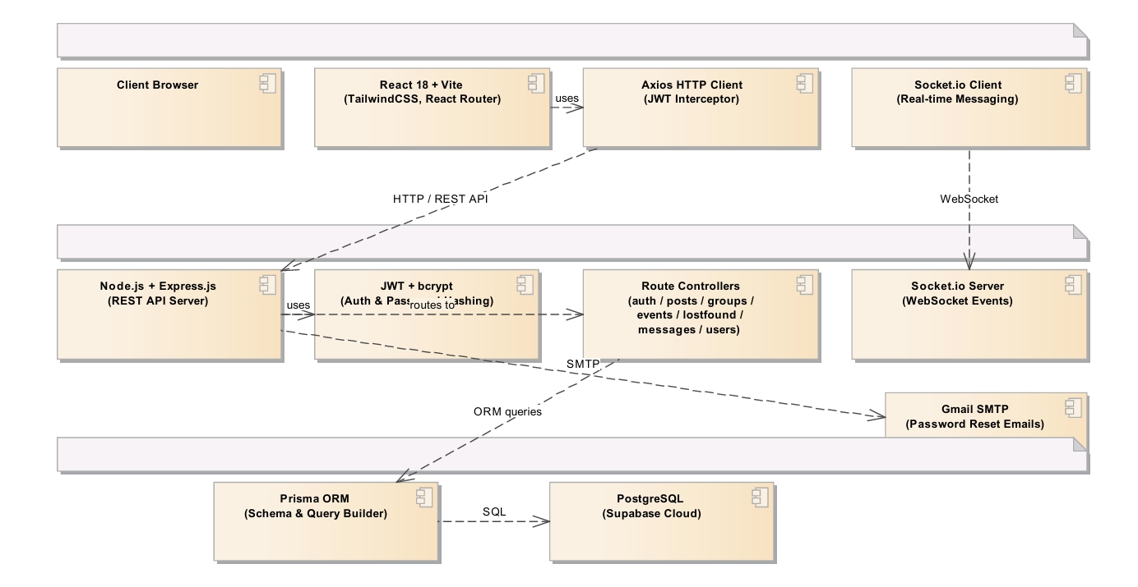

FIG 4.2
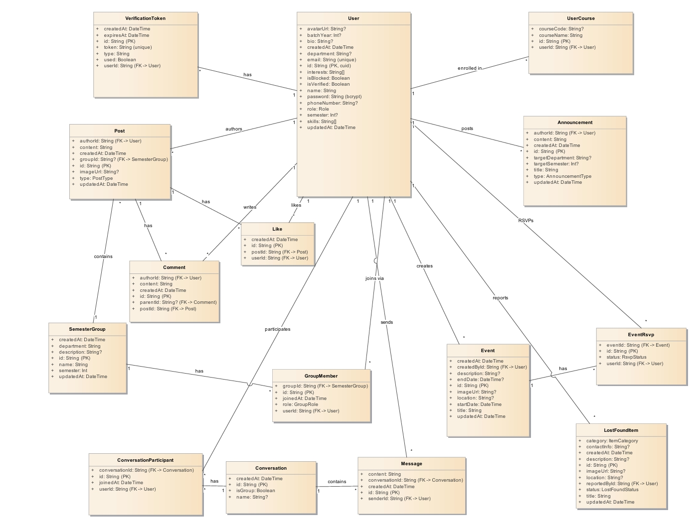

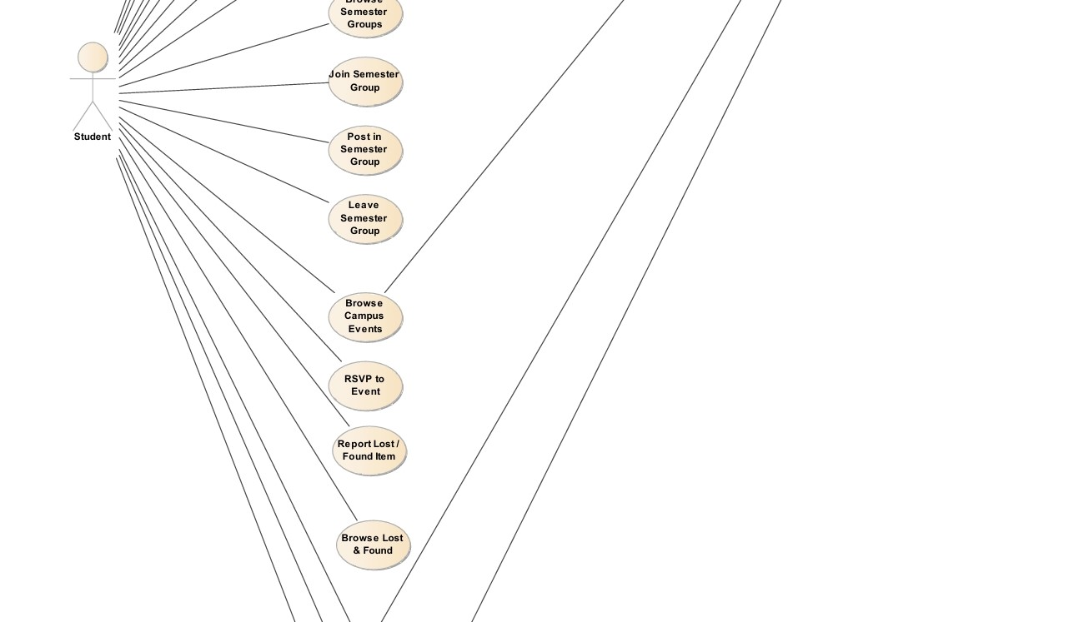
Fig 4.3